**ASSIGNMENTS ON DIGITAL MARKETING**

**NAME :** FORGIO ALWIN S

**DEPARTMENT :** BE COMPUTER SCIENCE

**COLLEGE :** 8151 DHANALAKSHMI SRINIVASAN INSTITUTE OF

TECHNOLOGY

**NAANMUDHALVAN COURSE**: DIGITAL MARKETING

**NM ID:** DBD5AS1A4AC96E7BD044A3FF6B012A

**ASSIGNMENT 1:**

Create a blog or website using Blogspot and WordPress. Customize

The theme design and post new article with 500 words.

<https://a2scabs.blogspot.com/>

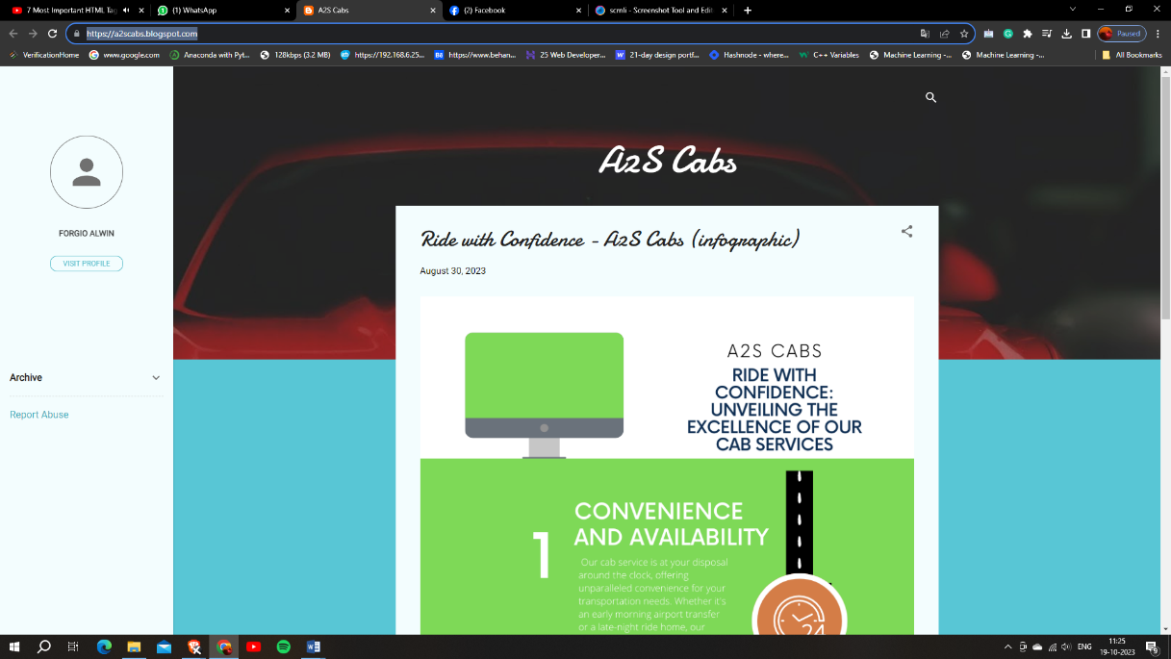

**ASSIGNMENT 2:**

Create a new Facebook business Page and Post one social media poster for your brand.

<https://www.facebook.com/AASCabs/>

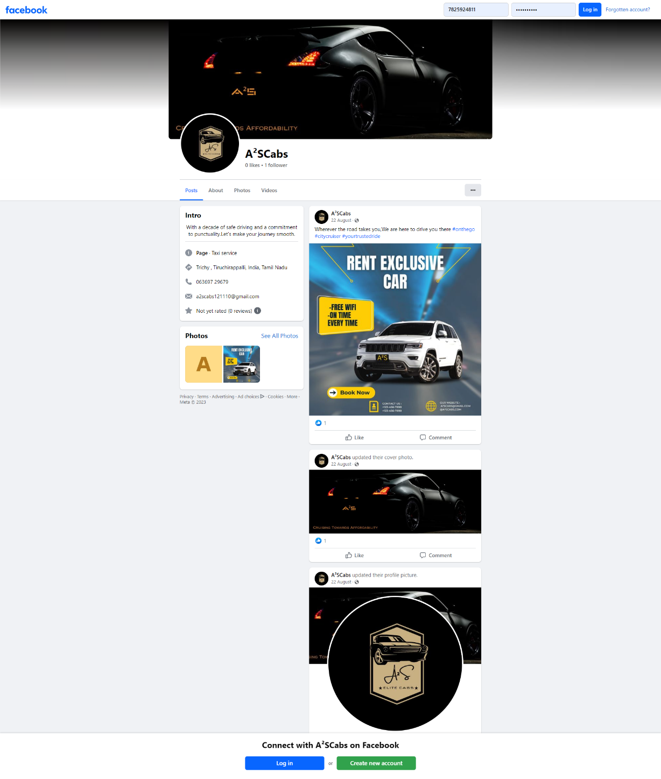

**ASSIGNMENT 3:**

Create and design a social media advertisement poster using Canva.



**ASSIGNMENT 4:**

4.Create email newsletter design using MailChimp or Canva tool.

